Neighbourhood Greenhouses - Seed Order Form

If you are new to square foot gardening or need more information relating to growing in the greenhouses check out the GROW Greenhouse Gardener 101 Guide.

Please Remember:

- Only seeds, soil amendments, fertilizers, and pest treatments provided by the program can be used in the greenhouses.
- No outside seeds are to be introduced into greenhouses in the interest of maintaining the health of these closed ecosystems.

Placing your seed order

Your greenhouse box is 2.5 feet x 8 feet which means you need to order enough seeds for 20 square feet. Think of putting a grid on your box and operating in squares (square foot gardening). Select the numbers below to decide how many square feet you would like per crop. Your order total should equal 20.

We will provide the correct number of seeds to plant per square foot for each crop type. For example, if you order 1 Calendula you will receive 9 seeds and you will spread them within 1 square foot, if you order 2 you will receive 18 seeds and you will spread them throughout 2 square feet. We will also take into account plants that can be succession planted.

Edible Flowers

CALENDULA: Daisy-like double flowers, ranging in warm colours from pink to burnt orange, are carried from spring to autumn. The edible flower petals will brighten up salads & are also used for making herbal remedies and teas. A good companion plant in the vegetable garden. Hardy annual. Height to 40 cm. Spread 30 cm. Germination 7 to 10 days. Planting depth 1/2"-1".

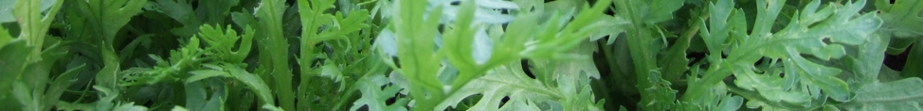

SHANGIKU: Edible Chrysanthyumum, harvest leaves before flowering. Harvest leaves when 4"- 6" tall, use young leaves to add a meaty taste to stir fry's (choy suey green), also used in Sukiyaki and sushi in Japan. Flowers and young leaves can also be used as a garnish or in salad. Annual. Planting depth 1/4"-1/2".

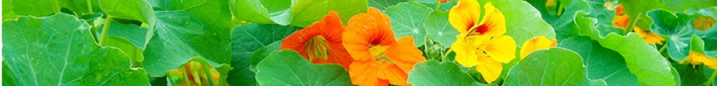

NASTURTIUM: A fast growing, bushy, tender, with rounded light to dark green leaves. Spurred trumpet-shaped flowers in shades of bright yellow to orange, appear from early summer to fall. Leaves & flower heads are edible, adding a sweet/spicy (and colourful) flavour to salads. Leaves excellent in stir-fry. Seeds can be pickled as capers. Height to 30 cm. Spread to 40 cm. Germination 7 to 10 days. Annual. Planting depth 1/2"-1".

Herbs

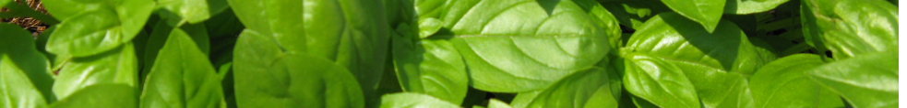

BASIL: Tender with large shiny bright green foliage, & a strong spicy fragrance. One of the easiest and most productive herbs to grow. Great for pesto! Pinch off growing tips & flowers for bushier plants and to delay flowering. Height 30 cm. Space plants 40 cm apart, harvest leaves as needed. Basil is a good greenhouse or container-grown plant. Germination 7 to 14 days. Maturation 30 days. Annual. Planting depth 1/8".

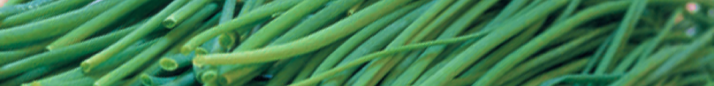

CHIVES: A delicate onion flavor perfect for almost any savory dish. Easy to grow. Snip the leaves in bunches at the base of the plant, then chop and use fresh or freeze for year-round use. Flowers added to salads are a colourful addition. Oils and vinegars can be flavored and colored by adding partially opened flower heads. Sow early spring or fall placing several seeds together to form a clump. Germination 7 to 10 days. Perennial. Planting depth 1/8".

CILANTRO: The herb with a unique strong, scent & taste, a staple ingredient in Mexican salsa & Thai cooking. Pale cream flower umbels are followed by seeds. Harvested dried seeds known as coriander. Lobed shaped, deeply divided green leaves. Height 45 cm. Space 25 cm apart & harvest as needed. Germination 7 to 14 days. Maturation 30 days. Hardy annual. Planting depth 1/4"-1/2".

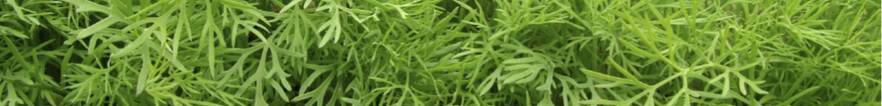

DILL: Aromatic foliage, flower heads & seeds are used in many dishes. Fast growing with finely cut blue-green foliage & yellow flower heads. Seeds can be chewed or brewed into tea for indigestion. Leaves, flower heads & seeds, fresh or dried all have culinary properties. Space plants 9 to 10 cm apart. Height to 1 m. Harvest as needed. Germination 7 to 14 days. Hardy Annual. Planting depth 1/8".

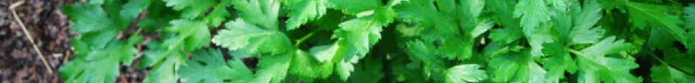

PARSLEY: Also known as Giant Catalogna because the plants can grow 60 cm tall. Easy-to-grow, lots of flavour and great for salads, soups, sauces and an attractive garnish. Great source of iron, minerals, and vitamins A and C. Flat glossy dark green leaves resemble those of celery. Sow seeds in early spring and thin plants 15 to 20 cm apart. Germination 14 to 21 days (slow). Biennial. Planting depth 1/8".

Beans & Peas

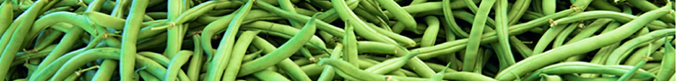

BUSH BEANS (Maxibel): Green, straight and string-less bean pods. Cut off beans, do not pull. Produces concentrated quantities! Pick beans regularly for continuous harvest. Germination 7-14 days, maturation: 45-55 days. *This plant will require a trellis to climb. Planting depth 1"-1 1/4".

WAX BUSH BEANS (Pencil Pod Golden Wax): Pale yellow, straight and string-less bean pods. Tender with a mildly sweet flavour. Harvest pods when firm/crisp. Eat fresh or preserve! Pick regularly for continuous harvest. Germination 7-14 days, maturation around 50 days. *This plant will require a trellis to climb. Planting depth 1"-1 1/4".

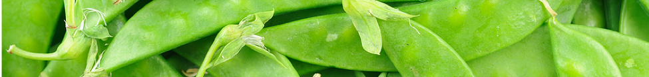

SNOW PEAS (Jim’s Oregon Giant): This exceptionally large pea variety grows on a semi leafless plant and is flat and tender, with an edible pod. Harvest when outline of peas appear in pod. Harvest regularly to promote flowering. Germination 7-14 days, maturation 55 days. Vines can reach 6' tall! *This plant will require a trellis to climb. Planting depth 1"-1 1/4".

SHELLING PEAS (Tall Telephone): Early producer on 1.5m plants. Broad pods hold 8-11 large, sweet, green peas. Flavourful and easy to shell. Germination 7-14 days, maturation 75. Vines reach 3-4ft. *This plant can be grown with or without support. Planting depth 1"-1 1/4".

Salad Greens

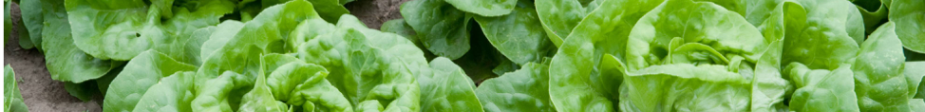

BUTTERHEAD LETTUCE: Very compact, heavy heads with green base and red edge. Thick wrapper leaves and large head. Harvest entire plant, thin, or cut and come again, then succession plant, slow to bolt. Germination 5-10 days, maturation 30 days. Planting depth 1/8"-1/4".

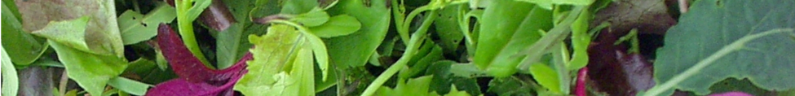

ALL WEATHER LETTUCE BLEND: Blend of salad-mix lettuces, including round, oak leaf, and frilly leaved lettuces and a mix of red, dark and light green colours. Straight lettuce, high-interest mix of salad greens that thrive in all weather. Thin. Succession plant every 2-3 weeks. Germination 7-14 days. Planting depth 1/8"-1/4".

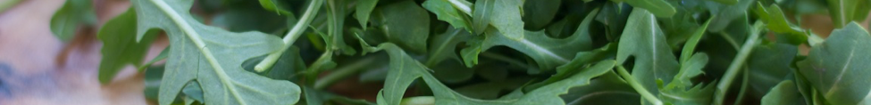

ARUGULA: Easy to grow. Flowers edible, young leaves milder than older ones, nutty/pepper taste. Cut and come again. Succession plant every 2-3 weeks. Germination 5-10 days, maturation 35 days. Planting depth 1/8"-1/4".

MIXED MUSTARD GREENS: Delicious and nutritious, mesclun mixture of the mustard family. Mix of mizuna, Osaka purple, arugula, tatsoi, among others. Use young leaves in salads and add in flowers for some fun, tasty colour; braise or steam leaves when mature. Cut and come again, succession plant, thin. Germination 5-10 days. Planting depth 1/8"-1/4".

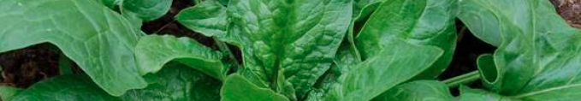

GIANT WINTER SPINACH: A hardy plant that produces large, vibrant green leaves. Leaves are great in salads, sandwiches or smoothies. Cut and come again, succession plant, thin. Tends to grow wide so make sure you leave enough room for it to mature without crowding neighbours. Harvest in 4-10 weeks if sown in early spring. Planting depth 1/8"-1/4".

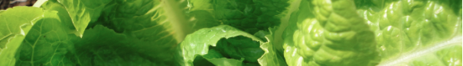

ROMAINE: This variety is known to stay sweet and crisp even in hot temperatures. Robust and bolt resistant this heat tolerant vegetable grows green, dense medium sized heads. Planting depth 1/8"-1/4".

Tomatoes

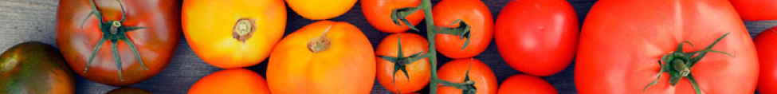

TOMATO plants can be ordered to a max of 4 in total. Numbers will be guaranteed but type is handed out on first come first serve basis. *Plants will require a support structure or tomato tower. Planting depth to first row of branches.

Tomato starts are lovingly provided by Goodfield Farm in Pemberton, BC.

Best of The Rest

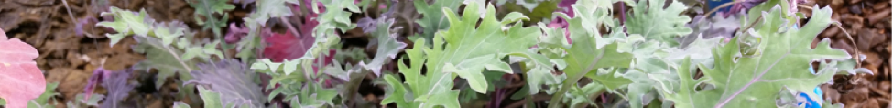

KALE, RUSSIAN RED: Most tender of all kales and very rich in vitamins and minerals. Use steamed, sautéed or raw. Cut and come again. Germination 7-14 days, maturation 50 days. Planting depth 1/8"-1/4".

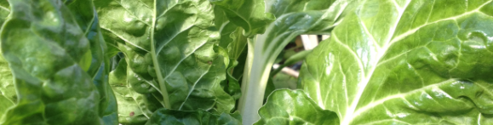

CHARD: Harvest outer leaves regularly, will continue to produce fresh greens, cut when leaves large enough to eat or cut entire plant 6"-8" above soil level. Germination 7-14 days. Planting depth 1/4"-1/2".

CUCUMBER: Crisp, sweet, and can grow quite large! Takes up a lot of space unless trellised. Germination 20 days, maturation 50-60 days. Planting depth 1/2"-3/4".

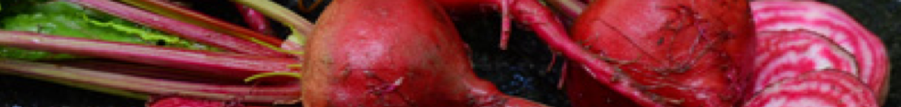

BEETS: Red medium size beet, easy way to fancy up any salad. Thin to prevent overcrowding. Germination 7-14 days, maturation 50-60 days. Planting depth 1"-1 1/4".

For more details on these seeds head to Full Circle Seeds - www.fullcircleseeds.com

